|  |  |  |
| --- | --- | --- |
| OPEN SOURCE PROGRAMMING | | |
|  |  |  |
| Online Notes Management System | | |

**REVIEW - 2**

**BY-**

**Rohin Srivastava 19BIT0177**

**Garvit Doda 19BIT0023**

# CODES –

**INDEX.PHP**

<!doctype html>

<html lang="en">

  <head>

    <title>Sidebar 03</title>

    <meta charset="utf-8">

    <meta name="viewport" content="width=device-width, initial-scale=1, shrink-to-fit=no">

    <link href="https://fonts.googleapis.com/css?family=Poppins:300,400,500,600,700,800,900" rel="stylesheet">

    <link rel="stylesheet" href="https://stackpath.bootstrapcdn.com/font-awesome/4.7.0/css/font-awesome.min.css">

    <link rel="stylesheet" href="css/style.css">

  </head>

  <body style="background-image:url('back3.jpeg');">

    <div class="wrapper d-flex align-items-stretch">

    <?php include('navigation.php')?>

        <!-- Page Content  -->

      <div id="content" class="p-4 p-md-5 pt-5">

        <h2 class="mb-4" style="text-align:right; font-family:'Lucida Handwriting';font-size:40px"><b>Welcome to our <br>Online Notes<br>

     Management System!</b></h2>

      </div>

    </div>

    <script src="js/jquery.min.js"></script>

    <script src="js/popper.js"></script>

    <script src="js/bootstrap.min.js"></script>

    <script src="js/main.js"></script>

  </body>

</html>

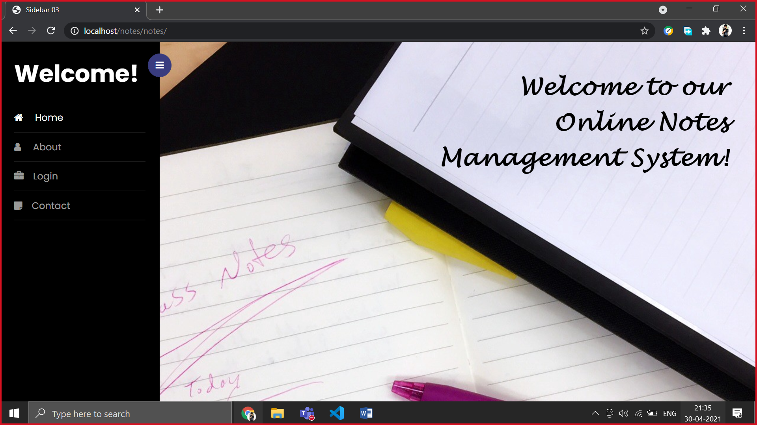

**ABOUT.PHP**

<!doctype html>

<html lang="en">

  <head>

    <title>Sidebar 03</title>

    <meta charset="utf-8">

    <meta name="viewport" content="width=device-width, initial-scale=1, shrink-to-fit=no">

    <link href="https://fonts.googleapis.com/css?family=Poppins:300,400,500,600,700,800,900" rel="stylesheet">

    <link rel="stylesheet" href="https://stackpath.bootstrapcdn.com/font-awesome/4.7.0/css/font-awesome.min.css">

    <link rel="stylesheet" href="css/style.css">

  </head>

  <body style="background-image:url('back7.jpg');">

    <div class="wrapper d-flex align-items-stretch">

    <?php include('navigation.php')?>

        <!-- Page Content  -->

      <div id="content" class="p-4 p-md-5 pt-5">

        <h2 class="mb-4"><b>About</b></h2>

        <p><div style="width:500px; color:black">

Online Notes Manager is a web based software that helps its users to create text based notes that might be handy for others too. So the portal will enable the user to upload notes online for other users. Therefore, it also has a download option for the users. The simplicity of the interface makes it easier to use and users can easily manage their notes or files online. Our efforts are to provide a web based application that helps users to create notes interactively.By using this platform, they can save their notes after creating and can also modify them whenever they want to.

    </div>

    </p>

      </div>

    </div>

    <script src="js/jquery.min.js"></script>

    <script src="js/popper.js"></script>

    <script src="js/bootstrap.min.js"></script>

    <script src="js/main.js"></script>

  </body>

</html>

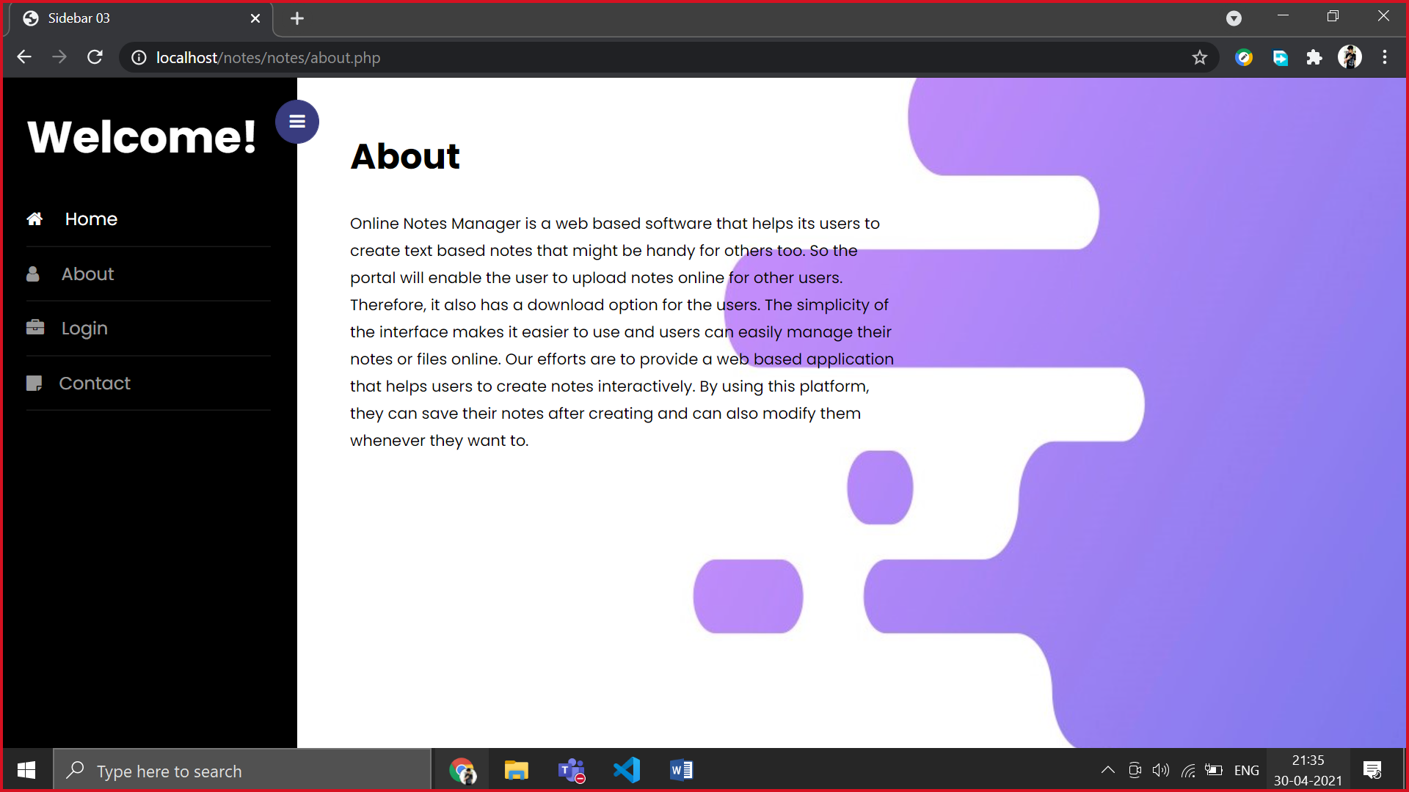

**CONTACT.PHP**

<!doctype html>

<html lang="en">

  <head>

    <title>Sidebar 03</title>

    <meta charset="utf-8">

    <meta name="viewport" content="width=device-width, initial-scale=1, shrink-to-fit=no">

    <link href="https://fonts.googleapis.com/css?family=Poppins:300,400,500,600,700,800,900" rel="stylesheet">

        <link rel="stylesheet" href="https://stackpath.bootstrapcdn.com/font-awesome/4.7.0/css/font-awesome.min.css">

        <link rel="stylesheet" href="css/style.css">

  </head>

  <body style="background-image:url('back7.jpg');">

        <div class="wrapper d-flex align-items-stretch">

        <?php include('navigation.php')?>

        <!-- Page Content  -->

      <div id="content" class="p-4 p-md-5 pt-5">

        <h2 class="mb-4"><b>Contact Us</b></h2>

        <div style="width:500px; color:black">

        <h3>How can we help you?</h3>

        Any queries regarding the working of the portal, reporting of bugs, collaboration related or any sort of issues are always welcomed!<br>

        If you have a question or a comment, please email us at any of the below emails- <br><br><br>

        sri.rohin184@gmail.com.<br>

        notes@gmail.com<br>

        garvit.doda@gmail.com<br>

        <br>

        <br>

        <br>Email should have queries and issues which are properly elaborated.Your issues will be resolved within 24 to 48 hours after reporting.

</div>

      </div>

        </div>

    <script src="js/jquery.min.js"></script>

    <script src="js/popper.js"></script>

    <script src="js/bootstrap.min.js"></script>

    <script src="js/main.js"></script>

  </body>

</html>

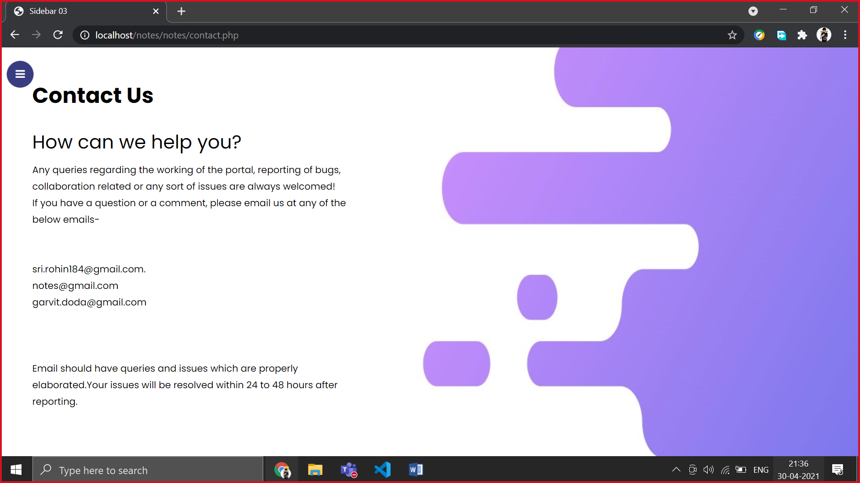

**REGISTER.PHP**

<?php include('server.php') ?>

<!DOCTYPE html>

<html>

<head>

  <title>Registration system PHP and MySQL</title>

  <link rel="stylesheet" type="text/css" href="rohin.css">

</head>

<body>

  <div class="header">

    <h2>Register</h2>

  </div>

  <form method="post" action="register.php">

    <?php include('errors.php'); ?>

    <div class="input-group">

      <label>Username</label>

      <input type="text" name="username" value="<?php echo $username; ?>">

    </div>

    <div class="">

        Are you a?<br>

        <input type="radio" id="student" name="type" value="student">

        <label for="student">Student</label>

        <input type="radio" id="teacher" name="type" value="teacher">

        <label for="teacher">Teacher</label>

    </div>

    <div class="input-group">

      <label>Email</label>

      <input type="email" name="email" value="<?php echo $email; ?>">

    </div>

    <div class="input-group">

      <label>Password</label>

      <input type="password" name="password_1">

    </div>

    <div class="input-group">

      <label>Confirm password</label>

      <input type="password" name="password_2">

    </div>

    <div class="input-group">

      <button type="submit" class="btn" name="reg_user">Register</button>

    </div>

    <p>Already a member? <a href="login.php">Sign in</a></p>

  </form>

</body>

</html>

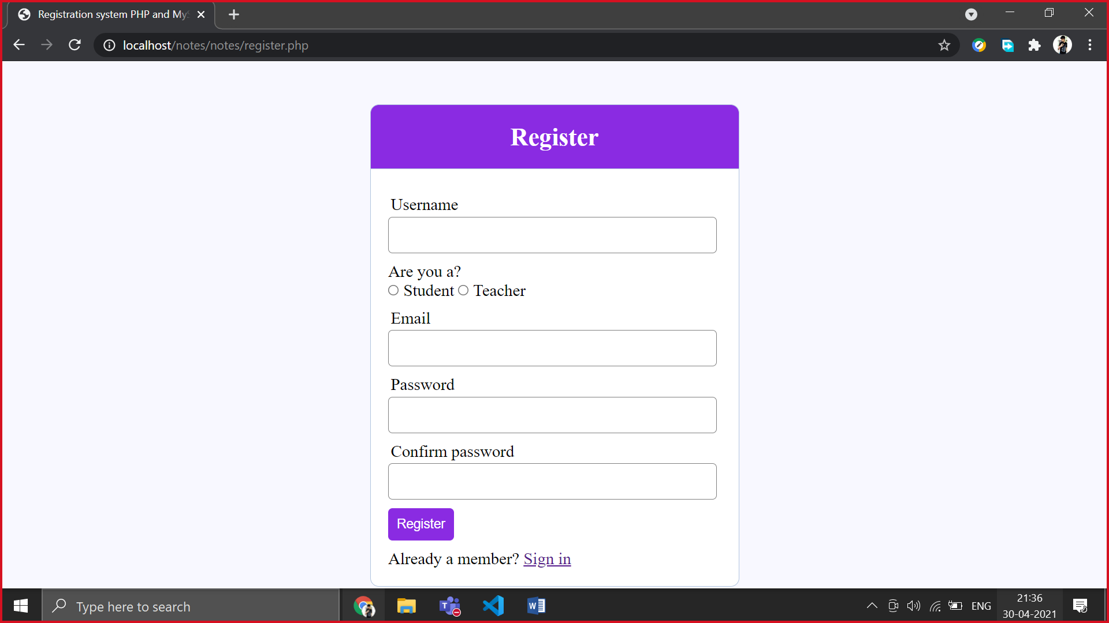

**LOGIN.PHP**

<?php include('server.php') ?>

<!DOCTYPE html>

<html>

<head>

  <title>Registration system PHP and MySQL</title>

  <link rel="stylesheet" type="text/css" href="rohin.css">

</head>

<body>

  <div class="header" >

    <h2>Login</h2>

  </div>

  <form method="post" action="login.php">

    <?php include('errors.php'); ?>

    <div class="input-group">

        <label>Username</label>

        <input type="text" name="username" >

    </div>

    <div class="input-group">

        <label>Password</label>

        <input type="password" name="password">

    </div>

    <div class="input-group">

        <button type="submit" class="btn" name="login_user">Login</button>

    </div>

    <p>

        Not yet a member? <a href="register.php">Sign up</a>

    </p>

  </form>

</body>

</html>

|  |  |
| --- | --- |
|  |  |

<?php

session_start();

// initializing variables

$username = "";

$email    = "";

$errors = array();

// connect to the database

$db = mysqli_connect('localhost', 'root', '', 'notes');

mysqli_query($db, "CREATE table Reg (username VARCHAR(50), email VARCHAR(50),

password VARCHAR(50), types varchar(50))");

// REGISTER USER

if (isset($_POST['reg_user'])) {

  // receive all input values from the form

  $username = mysqli_real_escape_string($db, $_POST['username']);

  $email = mysqli_real_escape_string($db, $_POST['email']);

  $password_1 = mysqli_real_escape_string($db, $_POST['password_1']);

  $password_2 = mysqli_real_escape_string($db, $_POST['password_2']);

  $types= mysqli_real_escape_string($db, $_POST['type']);

  // form validation: ensure that the form is correctly filled ...

  // by adding (array_push()) corresponding error unto $errors array

  if (empty($username)) { array_push($errors, "Username is required"); }

  if (empty($email)) { array_push($errors, "Email is required"); }

  if (empty($password_1)) { array_push($errors, "Password is required"); }

  if ($password_1 != $password_2) {

  array_push($errors, "The two passwords do not match");

  }

  // first check the database to make sure

  // a user does not already exist with the same username and/or email

  $user_check_query = "SELECT * FROM reg WHERE username='$username' OR email='$email' LIMIT 1";

  $result = mysqli_query($db, $user_check_query);

  $user = mysqli_fetch_assoc($result);

  if ($user) { // if user exists

    if ($user['username'] === $username) {

      array_push($errors, "Username already exists");

    }

    if ($user['email'] === $email) {

      array_push($errors, "email already exists");

    }

  }

  // Finally, register user if there are no errors in the form

  if (count($errors) == 0) {

    $password = $password_1;//encrypt the password before saving in the database

    $query = "INSERT INTO reg (username, email, password, types)

          VALUES('$username', '$email', '$password','$types')";

    mysqli_query($db, $query);

    $_SESSION['username'] = $username;

    $_SESSION['success'] = "You are now logged in";

    header('location: enter\index1.php');

  }

}

  if (isset($_POST['login_user'])) {

  $username = mysqli_real_escape_string($db, $_POST['username']);

  $password = mysqli_real_escape_string($db, $_POST['password']);

  if (empty($username)) {

    array_push($errors, "Username is required");

  }

  if (empty($password)) {

    array_push($errors, "Password is required");

  }

  if (count($errors) == 0) {

    $password = $password;

    $query = "SELECT * FROM reg WHERE username='$username' AND password='$password'";

    $results = mysqli_query($db, $query);

    echo $password.$username.mysqli_num_rows($results) ;

    if (mysqli_num_rows($results) == 1) {

      $_SESSION['username'] = $username;

      $_SESSION['success'] = "You are now logged in";

      header('location: enter\index1.php');

    }else {

      array_push($errors, "Wrong username/password combination");

    }

  }

}

?>

**AFTER LOGIN**

**CODE-**

INDEX1.PHP

<?php

//session_start(); //Add this

//Also you have to add your connection file before your query

require('..\server.php');

// SQL query

$strSQL = "SELECT * FROM reg WHERE username = '".$_SESSION['username']."'";

// Execute the query (the recordset $rs contains the result)

$rs = mysqli_query($db, $strSQL);

// Loop the recordset $rs

// Each row will be made into an array ($row) using mysqli_fetch_array

while($row = mysqli_fetch_array($rs)) {

  // Write the value of the column FirstName (which is now in the array $row)

  $a = $row['username'];

  $b = $row['email'];

}

// Close the database connection

mysqli_close($db);

?>

<!doctype html>

<html lang="en">

  <head>

    <title>Sidebar 02</title>

    <meta charset="utf-8">

    <meta name="viewport" content="width=device-width, initial-scale=1, shrink-to-fit=no">

    <link href="https://fonts.googleapis.com/css?family=Poppins:300,400,500,600,700,800,900" rel="stylesheet">

    <link rel="stylesheet" href="https://stackpath.bootstrapcdn.com/font-awesome/4.7.0/css/font-awesome.min.css">

    <link rel="stylesheet" href="css/style.css">

  </head>

  <style>

  </style>

  <body style="background-image:url('back3.jpg');">

    <div class="wrapper d-flex align-items-stretch">

    <?php include('navigation.php')?>

        <!-- Page Content  -->

      <div id="content" class="p-4 p-md-5 pt-5">

        <div style="width:600px;color:black;font-size:60px;margin-top:130px;margin-left:140px;text-shadow:8px 8px 4px skyblue">

        <b>Welcome!</b><i class="fa fa-home" aria-hidden="true"></i><br>

        <?php echo $a?>

        </div>

        <div  style="width:600px;color:black;font-size:20px;margin-left:140px;">Enjoy our website! Create Upload Download Repeat!</div>

        </div>

    </div>

    <script src="js/jquery.min.js"></script>

    <script src="js/popper.js"></script>

    <script src="js/bootstrap.min.js"></script>

    <script src="js/main.js"></script>

  </body>

</html>

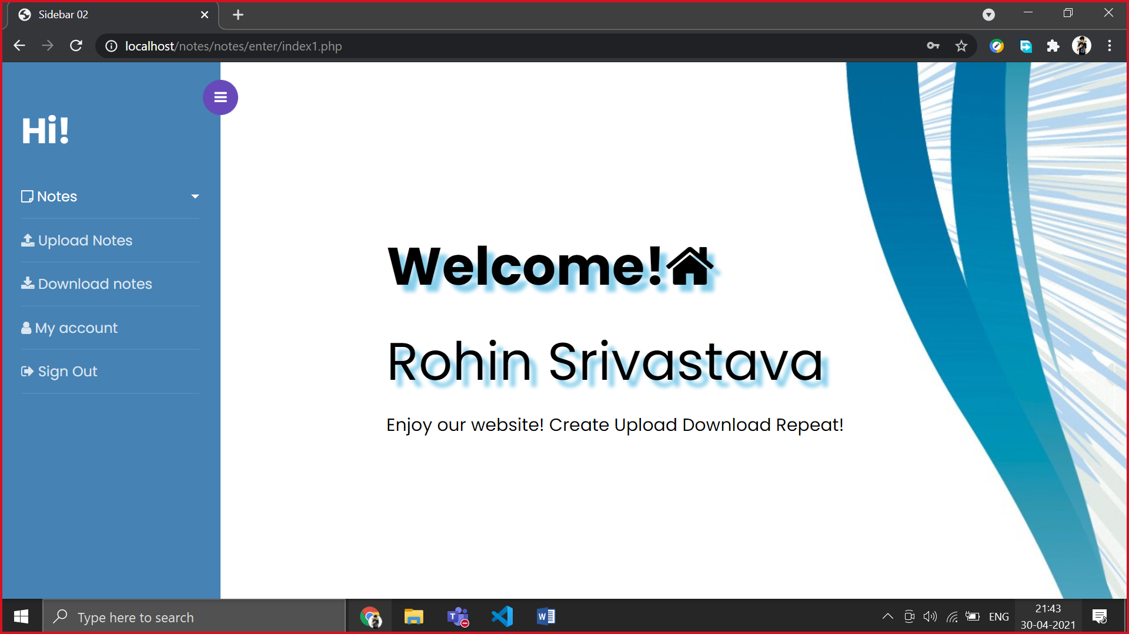

**MYACCOUNT.PHP**

<?php

//session_start(); //Add this

//Also you have to add your connection file before your query

require('..\server.php');

// SQL query

$strSQL = "SELECT * FROM reg WHERE username = '".$_SESSION['username']."'";

// Execute the query (the recordset $rs contains the result)

$rs = mysqli_query($db, $strSQL);

// Loop the recordset $rs

// Each row will be made into an array ($row) using mysqli_fetch_array

while($row = mysqli_fetch_array($rs)) {

  // Write the value of the column FirstName (which is now in the array $row)

  $a = $row['username'];

  $b = $row['email'];

}

// Close the database connection

mysqli_close($db);

?>

<!doctype html>

<html lang="en">

  <head>

    <title>Sidebar 02</title>

    <meta charset="utf-8">

    <meta name="viewport" content="width=device-width, initial-scale=1, shrink-to-fit=no">

    <link href="https://fonts.googleapis.com/css?family=Poppins:300,400,500,600,700,800,900" rel="stylesheet">

    <link rel="stylesheet" href="https://stackpath.bootstrapcdn.com/font-awesome/4.7.0/css/font-awesome.min.css">

    <link rel="stylesheet" href="css/style.css">

    <style>

        .card {

        box-shadow: 0 4px 8px 0 rgba(0, 0, 0, 0.2);

        max-width: 500px;

        margin: auto;

        text-align: center;

        }

        .title {

        color: grey;

        font-size: 18px;

        }

        button {

        border: none;

        outline: 0;

        display: inline-block;

        padding: 8px;

        color: white;

        background-color: #000;

        text-align: center;

        cursor: pointer;

        width: 100%;

        font-size: 18px;

        }

        button:hover, a:hover {

        opacity: 0.7;

        }

    </style>

  </head>

  <body style="background-image:url('back3.jpg');">

    <div class="wrapper d-flex align-items-stretch">

    <?php include('navigation.php')?>

        <!-- Page Content  -->

      <div id="content" class="p-4 p-md-5 pt-5">

        <div style="text-align:center;font-size:60px;color:black">User Profile</div>

        <div class="card">

        <img src="..\I1\usericon.jpg" alt="John" style="width:70%; padding-left:155px;">

        <h1><?php echo $a?></h1>

        <p class="title"><?php echo $b?></p>

        <div style="margin: 24px 0;">

        </div>

        <p><button style="background-color:#4682B4">Edit Profile</button></p>

        </div>

      </div>

    </div>

    <script src="js/jquery.min.js"></script>

    <script src="js/popper.js"></script>

    <script src="js/bootstrap.min.js"></script>

    <script src="js/main.js"></script>

  </body>

</html>

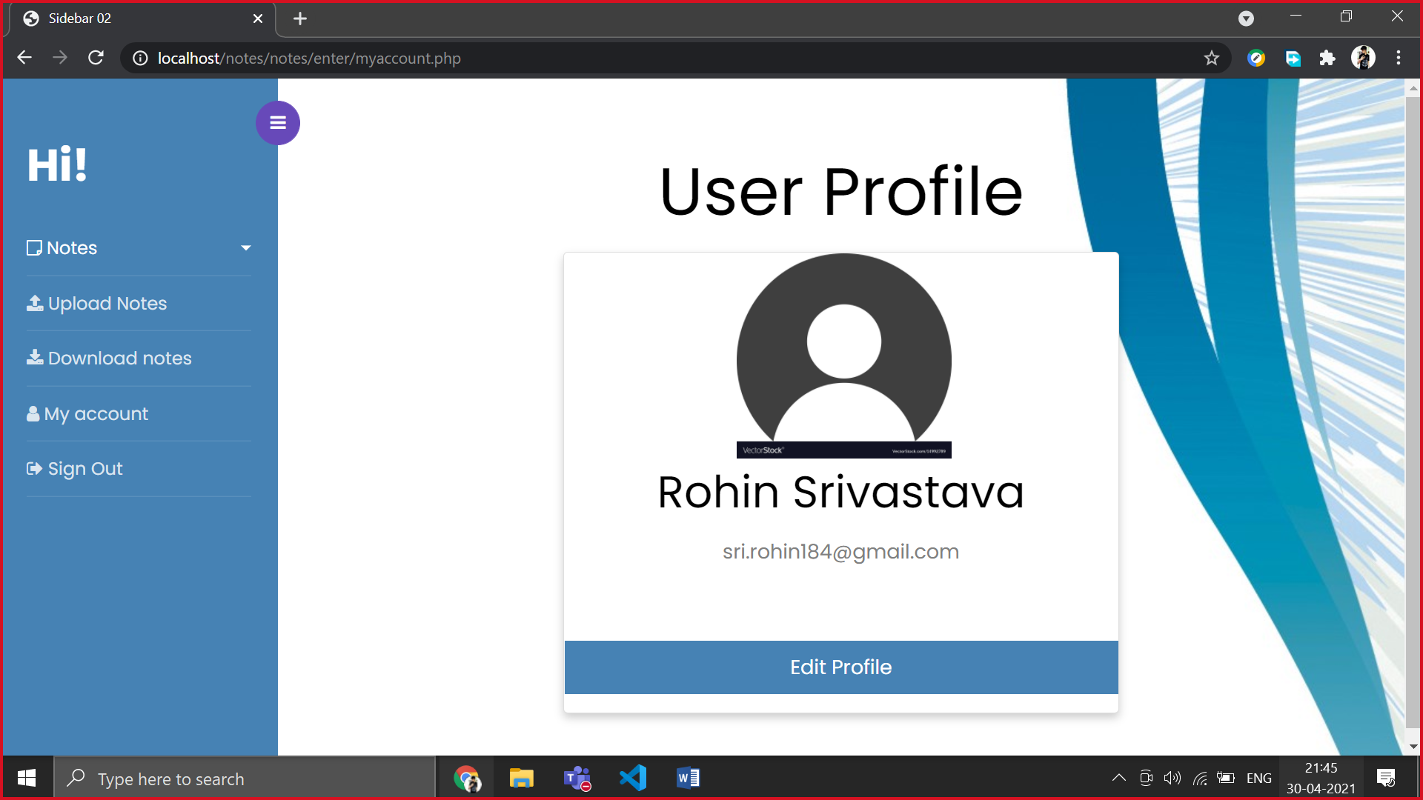

**UPLOADN.PHP**

<!doctype html>

<html lang="en">

  <head>

    <title>Sidebar 02</title>

    <meta charset="utf-8">

    <meta name="viewport" content="width=device-width, initial-scale=1, shrink-to-fit=no">

    <link href="https://fonts.googleapis.com/css?family=Poppins:300,400,500,600,700,800,900" rel="stylesheet">

    <link rel="stylesheet" href="https://stackpath.bootstrapcdn.com/font-awesome/4.7.0/css/font-awesome.min.css">

    <link rel="stylesheet" href="css/style.css">

  </head>

  <style>

.file-area {

  width: 100%;

  position: relative;

  input[type=file] {

    position: absolute;

    width: 100%;

    height: 100%;

    top: 0;

    left: 0;

    right: 0;

    bottom: 0;

    opacity: 0;

    cursor: pointer;

  }

  .file-dummy {

    width: 100%;

    padding: 30px;

    background: rgba(255,255,255,0.2);

    border: 2px dashed rgba(255,255,255,0.2);

    text-align: center;

    transition: background 0.3s ease-in-out;

    .success {

      display: none;

    }

  }

  &:hover .file-dummy {

    background: rgba(255,255,255,0.1);

  }

  input[type=file]:focus + .file-dummy {

    outline: 2px solid rgba(255,255,255,0.5);

    outline: -webkit-focus-ring-color auto 5px;

  }

  input[type=file]:valid + .file-dummy {

    border-color: rgba(0,255,0,0.4);

    background-color: rgba(0,255,0,0.3);

    .success {

      display: inline-block;

    }

    .default {

      display: none;

    }

  }

}

label {

  font-weight: 500;

  display: block;

  margin: 4px 0;

  font-size: 18px;

  overflow: hidden;

}

.form-controll {

  display: block;

  padding: 8px 16px;

  width: 100%;

  font-size: 16px;

  background-color: rgba(255,255,255,0.2);

  border: 1px solid black;

  color: black;

  font-weight: 200;

}

button {

  padding: 10px 40px;

  background: blueviolet;

  color: white;

  text-transform: uppercase;

  font-weight: 500;

  font-size: 14px;

  border: 0;

  cursor: pointer;

}

.form-group {

  max-width: 500px;

  margin: auto;

  margin-bottom: 30px;

}

  </style>

  <body style="background-image:url('back3.jpg');">

    <div class="wrapper d-flex align-items-stretch">

    <?php include('navigation.php')?>

      <div id="content" class="p-4 p-md-5 pt-5" style="text-align:left;">

      <form action method="post">

  <h1 style="text-align:center;"><strong>File upload</strong></h1>

  <div class="form-group" >

    <label style="color:black;" for="title">Subject</label>

    <select name="subject" id="subject" class="form-controll">

    <option>Select</option>

    <option value="maths">Maths</option>

    <option value="physics">Physics</option>

    <option value="chemistry">Chemistry</option>

    <option value="english">English</option>

  </select>

  </div>

  <div class="form-group">

    <label style="color:black;" for="caption">Description</label>

    <input type="text" name="caption" id="caption" class="form-controll"/>

  </div>

  <div class="form-group file-area">

    <input type="file" name="images" id="images" required="required" multiple="multiple"/>

  </div>

  <div class="form-group">

    <button type="submit" style="background-color:#4682B4">Upload</button>

  </div>

</form>

<link href='https://fonts.googleapis.com/css?family=Lato:100,200,300,400,500,600,700' rel='stylesheet' type='text/css'>

      </div>

    </div>

    <script src="js/jquery.min.js"></script>

    <script src="js/popper.js"></script>

    <script src="js/bootstrap.min.js"></script>

    <script src="js/main.js"></script>

  </body>

</html>

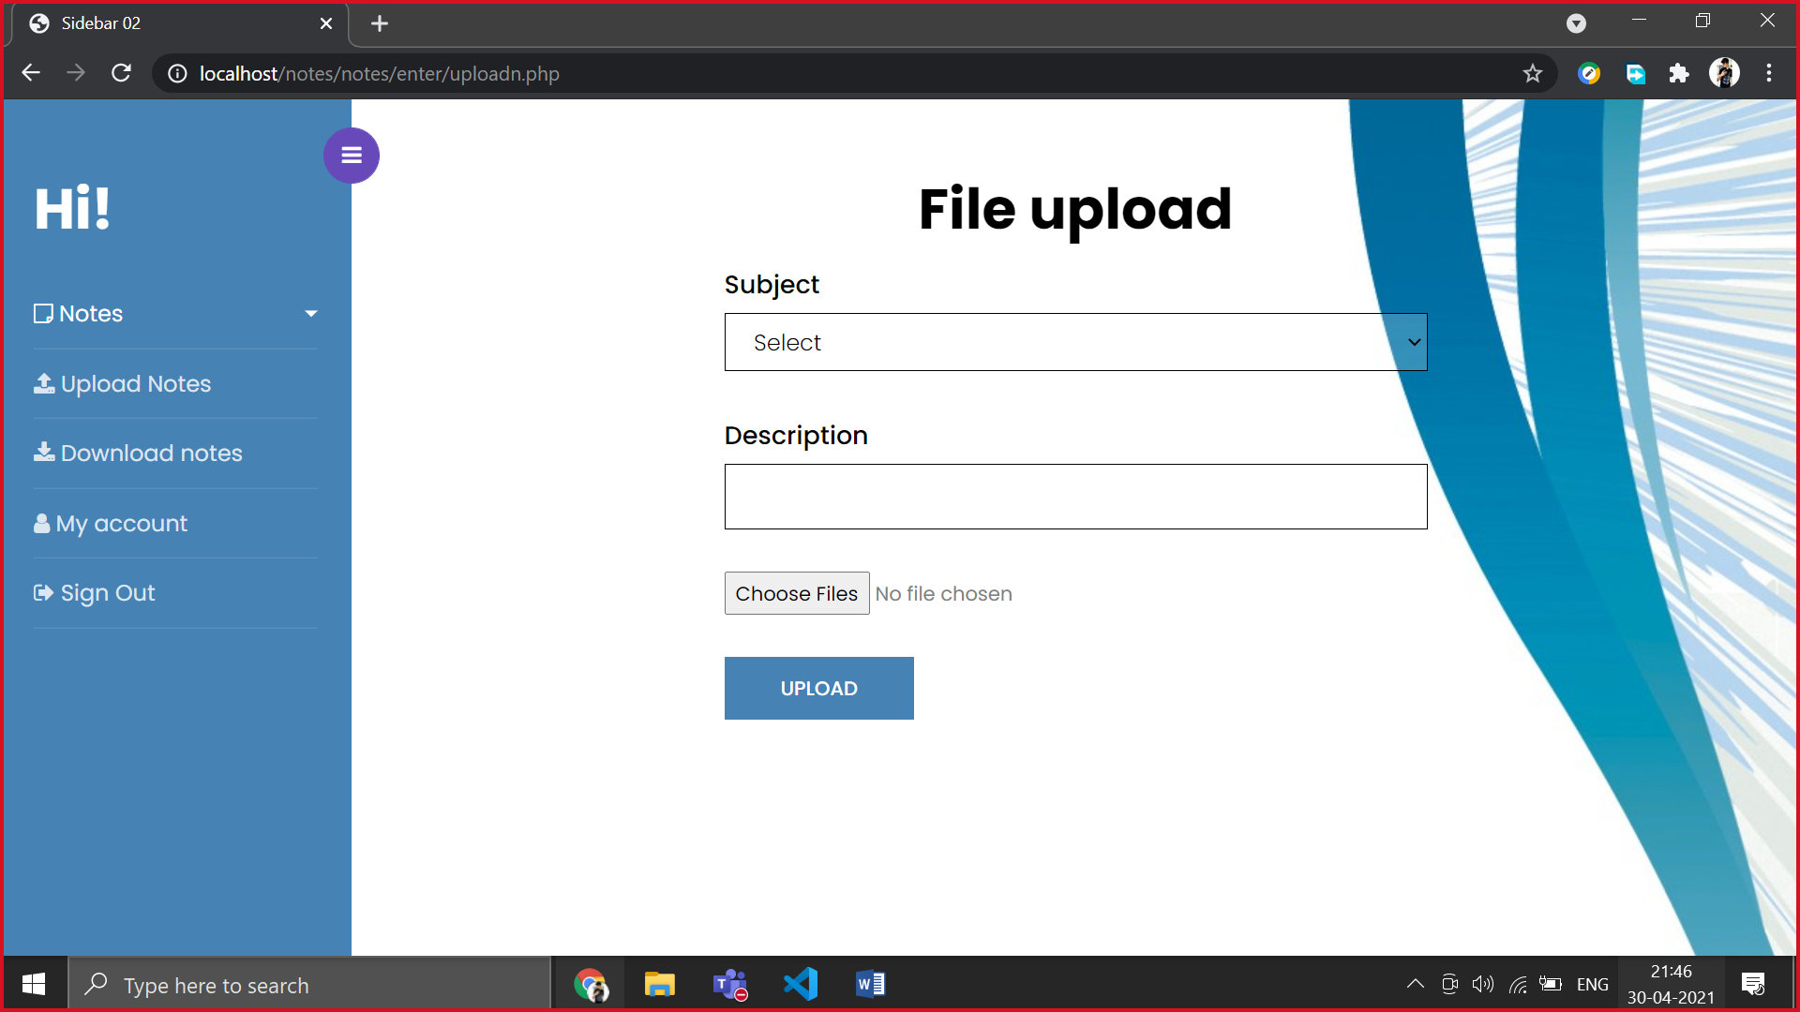

**DOWNLOADN.PHP**

<!doctype html>

<html lang="en">

  <head>

    <title>Sidebar 02</title>

    <meta charset="utf-8">

    <meta name="viewport" content="width=device-width, initial-scale=1, shrink-to-fit=no">

    <link href="https://fonts.googleapis.com/css?family=Poppins:300,400,500,600,700,800,900" rel="stylesheet">

    <link rel="stylesheet" href="https://stackpath.bootstrapcdn.com/font-awesome/4.7.0/css/font-awesome.min.css">

    <link rel="stylesheet" href="css/style.css">

        <style>

.dropbtn {

  background-color: #ad6beb;

  color: white;

  padding: 16px;

  font-size: 16px;

  border: none;

  cursor: pointer;

}

.dropbtn:hover, .dropbtn:focus {

  background-color: #a760e9;

}

#myInput {

  box-sizing: border-box;

  background-image: url('searchicon.png');

  background-position: 14px 12px;

  background-repeat: no-repeat;

  font-size: 16px;

  padding: 14px 20px 12px 45px;

  border: none;

  border-bottom: 1px solid #ddd;

}

#myInput:focus {outline: 3px solid #ddd;}

.dropdown {

  position: relative;

  display: inline-block;

}

.dropdown-content {

  display: none;

  position: absolute;

  background-color: #f6f6f6;

  min-width: 230px;

  overflow: auto;

  border: 1px solid #ddd;

  z-index: 1;

}

.dropdown-content a {

  color: black;

  padding: 12px 16px;

  text-decoration: none;

  display: block;

}

.dropdown a:hover {background-color: #ddd;}

.show {display: block;}

</style>

  </head>

  <body style="background-image:url('back3.jpg');">

    <div class="wrapper d-flex align-items-stretch">

    <?php include('navigation.php')?>

        <!-- Page Content  -->

      <div id="content" class="p-4 p-md-5 pt-5">

      <h2>Download Notes</h2>

        <p>Click on the button to open the dropdown menu, and use the input field to search for a specific dropdown link.</p>

        <div class="dropdown">

        <button onclick="myFunction()" class="dropbtn" style="background-color:#4682B4">Subjects</button>

        <div id="myDropdown" class="dropdown-content">

        <input type="text" placeholder="Search.." id="myInput" onkeyup="filterFunction()">

        <a href="#about">Maths</a>

        <a href="#base">Physics</a>

        <a href="#blog">Chemistry</a>

        <a href="#contact">English</a>

      </div>

        </div>

    <script>

    /* When the user clicks on the button,

    toggle between hiding and showing the dropdown content */

    function myFunction() {

    document.getElementById("myDropdown").classList.toggle("show");

    }

    function filterFunction() {

    var input, filter, ul, li, a, i;

    input = document.getElementById("myInput");

    filter = input.value.toUpperCase();

    div = document.getElementById("myDropdown");

    a = div.getElementsByTagName("a");

    for (i = 0; i < a.length; i++) {

        txtValue = a[i].textContent || a[i].innerText;

        if (txtValue.toUpperCase().indexOf(filter) > -1) {

        a[i].style.display = "";

        }

        else {

        a[i].style.display = "none";

        }

    }

    }

    </script>

      </div>

    </div>

    <script src="js/jquery.min.js"></script>

    <script src="js/popper.js"></script>

    <script src="js/bootstrap.min.js"></script>

    <script src="js/main.js"></script>

  </body>

</html>

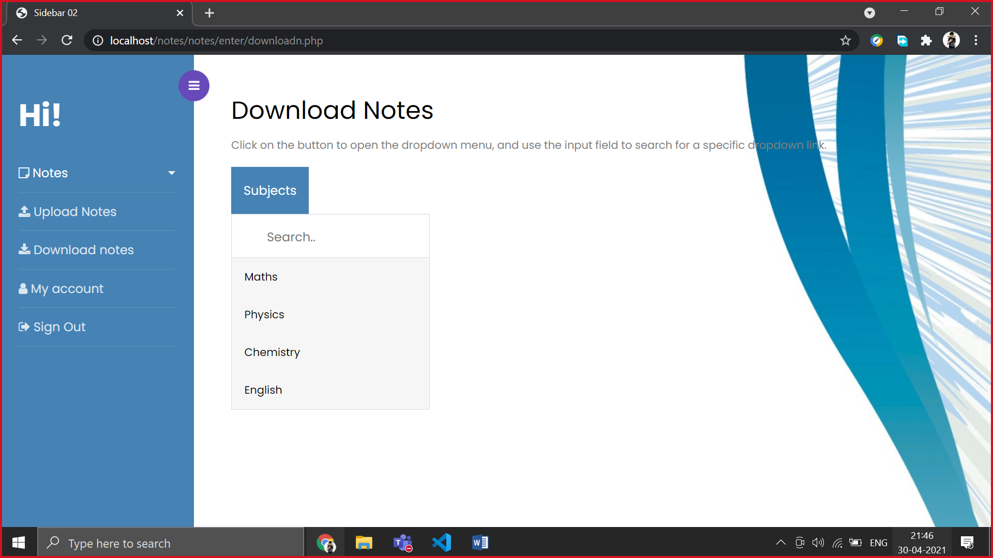

**CREATEN.PHP**

<!doctype html>

<html lang="en">

  <head>

    <title>Create Notes</title>

    <meta charset="utf-8">

    <meta name="viewport" content="width=device-width, initial-scale=1, shrink-to-fit=no">

    <link href="https://fonts.googleapis.com/css?family=Poppins:300,400,500,600,700,800,900" rel="stylesheet">

        <link rel="stylesheet" href="https://stackpath.bootstrapcdn.com/font-awesome/4.7.0/css/font-awesome.min.css">

        <link rel="stylesheet" href="css/style.css">

  </head>

  <style>

  *{

margin:0;

padding: 0;

box-sizing: border-box;

}

form{

margin: 10px 0;

}

button{

border: none;

outline: none;

width:30px;

height: 30px;

cursor: pointer;

}

#output{

width: 700px;

height: 400px;

border: 1px solid #111;

}

</style>

  <body style="background-image:url('back3.jpg');">

        <div class="wrapper d-flex align-items-stretch">

        <?php include('navigation.php')?>

      <div id="content" class="p-4 p-md-5 pt-5">

      <h1>Create Notes</h1>

      <link rel="stylesheet" href="https://cdnjs.cloudflare.com/ajax/libs/font-awesome/4.7.0/css/font-awesome.min.css">

      <form >

        <button type="button" data-cmd="justifyLeft">

            <i class="fa fa-align-left" aria-hidden="true"></i>

        </button>

        <button type="button" data-cmd="justifyCenter">

            <i class="fa fa-align-center" aria-hidden="true"></i>

        </button>

        <button type="button" data-cmd="justifyFull">

            <i class="fa fa-align-justify" aria-hidden="true"></i>

        </button>

        <button type="button" data-cmd="justifyRight">

            <i class="fa fa-align-right" aria-hidden="true"></i>

        </button>

        <button type="button" data-cmd="bold">

            <i class="fa fa-bold" aria-hidden="true"></i>

        </button>

        <button type="button" data-cmd="italic">

            <i class="fa fa-italic" aria-hidden="true"></i>

        </button>

        <button type="button" data-cmd="underline">

            <i class="fa fa-underline" aria-hidden="true"></i>

        </button>

        <button type="button" data-cmd="insertOrderedList">

            <i class="fa fa-list-ol" aria-hidden="true"></i>

        </button>

        <button type="button" data-cmd="insertUnorderedList">

            <i class="fa fa-list-ul" aria-hidden="true"></i>

        </button>

        <button type="button" data-cmd="insertImage">

            <i class="fa fa-file-image-o" aria-hidden="true"></i>

        </button>

        <button type="button" data-cmd="createLink">

            <i class="fa fa-link" aria-hidden="true"></i>

        </button>

        <button type="button" data-cmd="showCode" name="active">

            <i class="fa fa-code" aria-hidden="true"></i>

        </button>

    </form>

    <form method="post">

    <iframe id="output" name="textField" ></iframe><br>

    <input type="submit" name="button" style="background-color:#4682B4;width:100px;color:white" value="Save"/>

    <script>

    const a=document.getElementById("output");

    let b;

    function f(){

      b=a.contentDocument.innerHTML;

      $("#abc").val(String(b));

      console.log(b);

    }

    </script>

    </form>

    <script>

        const buttons=document.querySelectorAll('button');

        textField.document.designMode="On";

        let show=false;

        for(let i=0;i<buttons.length;i++)

        {

            buttons[i].addEventListener('click',()=>{

                let cmd=buttons[i].getAttribute('data-cmd');

                if(buttons[i].name==="active"){

                    buttons[i].classList.toggle('active');

                }

                if(cmd==="insertImage"||cmd==="createLink"){

                    let url=prompt("enter link here:","");

                    textField.document.execCommand(cmd,false,url);

                    if(cmd==="insertImage"){

                        const imgs=textField.document.querySelectorAll('img');

                        imgs.forEach(item=>{

                            item.style.maxWidth="500px";

                        })

                    }

                    else{

                        const links=textField.document.querySelectorAll('a');

                        links.forEach(item=>{

                            item.target="_blank";

                            item.addEventListener('mouseover',()=>{

                                textField.document.designMode="Off";

                            });

                            item.addEventListener('mouseover',()=>{

                                textField.document.designMode="On";

                            });

                        })

                    }

                }

                else{

                    textField.document.execCommand(cmd,false,null);

                }

                if(cmd==="showCode"){

                    const textBody=textField.document.querySelector('body');

                    if(show){

                        textBody.innerHTML=textBody.textContent;

                        show=false;

                    }else{

                        textBody.textContent=textBody.innerHTML;

                        show=true;

                    }

                }

            })

        }

        </script>

      </div>

        </div>

    <script src="js/jquery.min.js"></script>

    <script src="js/popper.js"></script>

    <script src="js/bootstrap.min.js"></script>

    <script src="js/main.js"></script>

  </body>

</html>

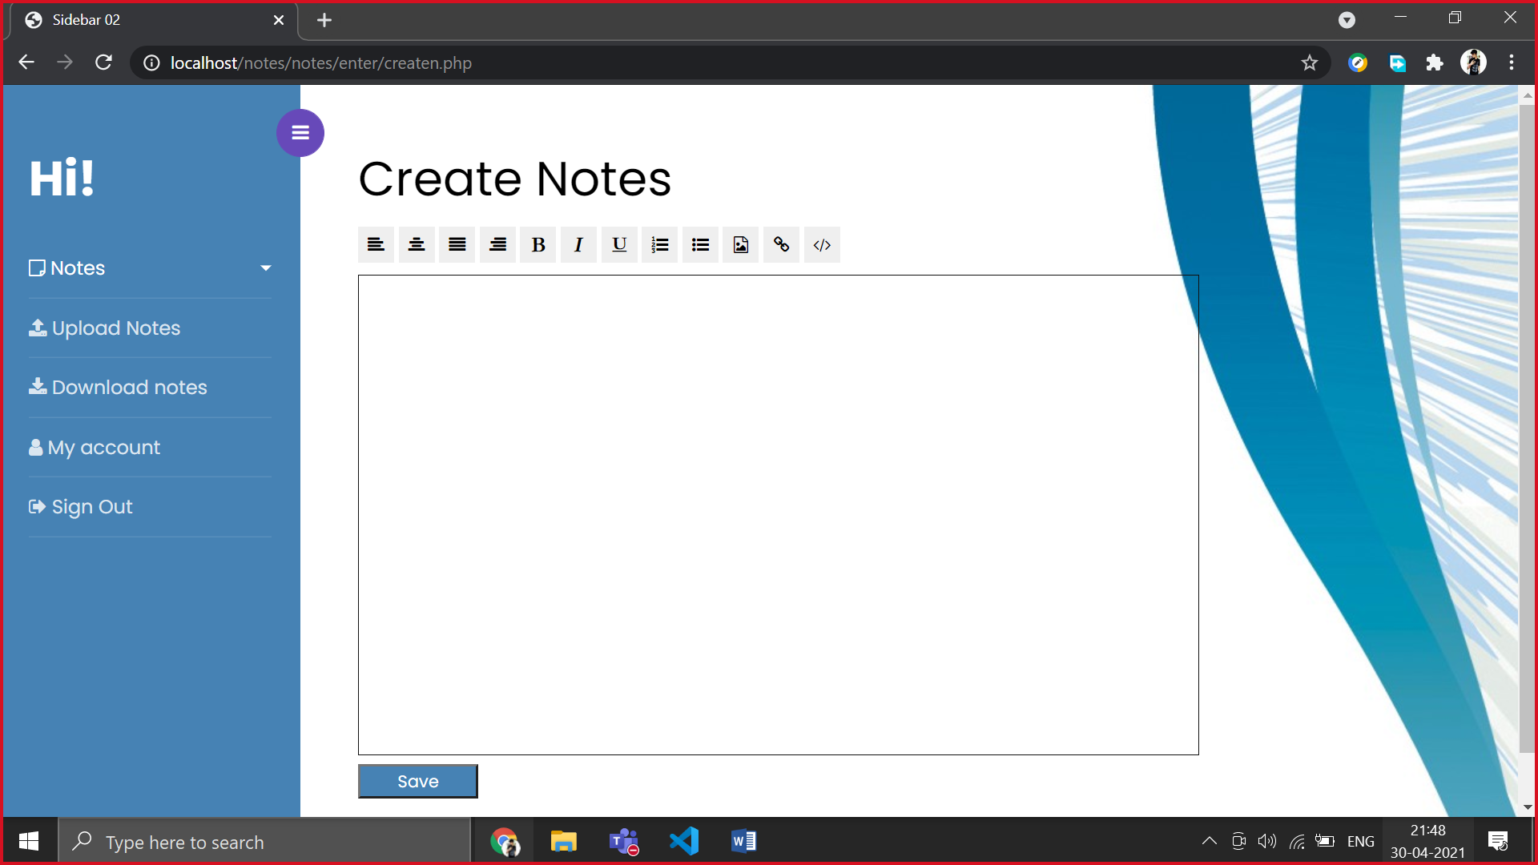

**ENTITY RELATIONSHIP DIAGRAM**

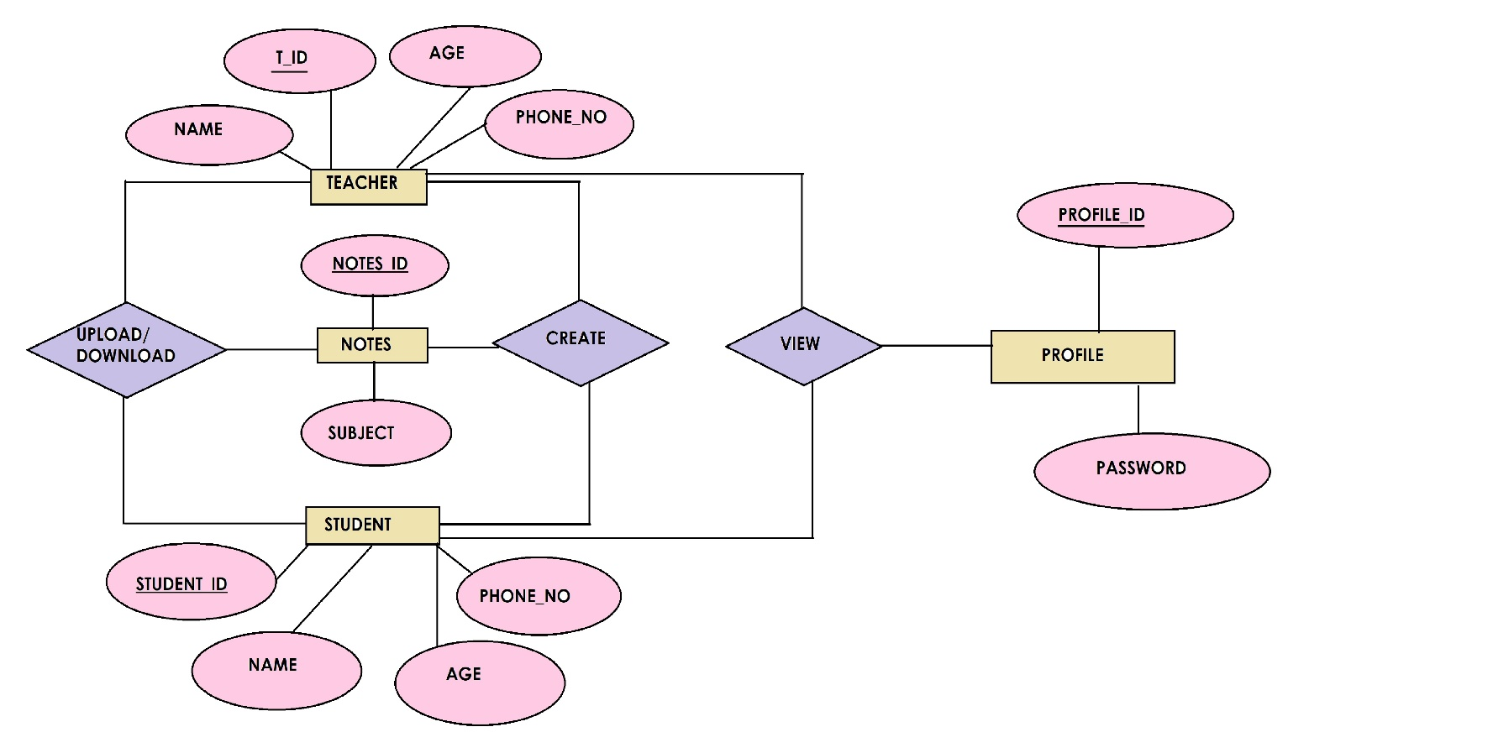

**TABLES IN OUR DATABASE**

* Registration(username(pk),email,password,types);
* Notes (notes_id(pk),subject,types)
* Saved Notes(notes_id(pk),subject,types)